**Project Design Phase-II**

**Data Flow Diagram & User Stories**

|  |  |
| --- | --- |
| Date | 19 June 2025 |
| Team ID | LTVIP2025TMID32454 |
| Project Name | Clean Tech:Transforming Waste Management with Transfer learning |
| Maximum Marks | 4 Marks |

**Data Flow Diagrams:**

A Data Flow Diagram (DFD) is a traditional visual representation of the information flows within a system. A neat and clear DFD can depict the right amount of the system requirement graphically. It shows how data enters and leaves the system, what changes the information, and where data is stored.

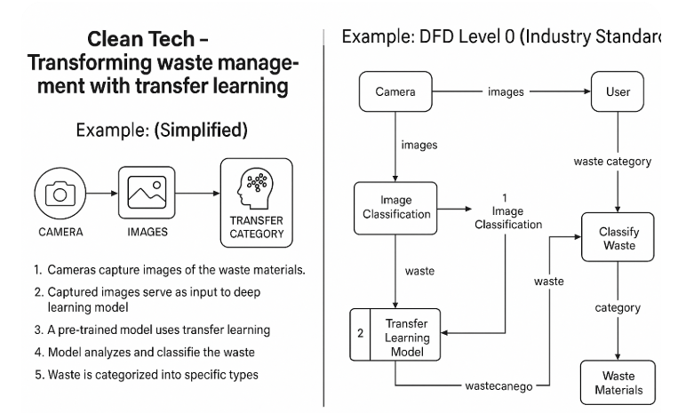**Example:** [**(Simplified)**](https://developer.ibm.com/patterns/visualize-unstructured-text/)

**User Stories**

Use the below template to list all the user stories for the product.

| **User Type** | **Functional Requirement (Epic)** | **User Story Number** | **User Story / Task** | **Acceptance criteria** | **Priority** | **Release** |
| --- | --- | --- | --- | --- | --- | --- |
| System (Smart Sorter – Recycling Center) | Waste Image Capture & Classification | USN-1 | As a system, I want to capture images of waste from conveyor belts so that the classification process can begin.. | Images are captured every 2 seconds and stored for processing. | High | Sprint-1 |
| System | Waste Classification using Transfer Learning | USN-2 | As a system, I want to identify waste items from images as recyclable or non-recyclable. | Images are classified with 90%+ accuracy into defined waste categories. | High | Sprint-1 |
| Operator (Recycling Center Worker) | Sorting Feedback | USN-3 | As a user, I can register for the application through Facebook | Corrections are logged and used in model retraining. | Low | Sprint-2 |
| City Admin (Smart City) | Public Bin Monitoring | USN-4 | As a user, I can register for the application through Gmail | Bin camera captures and classifies waste into Organic, Recyclable, or General. | Medium | Sprint-1 |
| System | Alerting & Bin Overflow Detection | USN-5 | As a user, I can log into the application by entering email & password | Alert is sent to admin dashboard or app when threshold is reached. | High | Sprint-1 |
| Factory Supervisor | Waste Monitoring | USN-6 | As a factory supervisor, I want the system to classify industrial waste like plastic, metal, or hazardous waste. | Industrial waste is categorized and compliance is logged. | Low | Sprint-3 |
| System | Compliance Reporting | USN-7 | As a system, I want to generate weekly reports of waste classification accuracy and segregation logs. | Report available in dashboard by end of week. | Medium | Sprint-4 |
| Admin | Model Training & Tuning | USN-8 | As an admin, I want to retrain the classification model periodically using corrected data. | Retrained model shows improved accuracy in subsequent runs.. | High | Sprint-4 |
|  |  |  |  |  |  |  |